COURSE MEASUREMENT REPORT
- REPORT FOR NATIONAL CERTIFIED COURSE –
INFORMATION ABOUT EVENT AND COURSE
Event: Bergen City Milen
Technical Organiser: TIF Viking
City/Place : Bergen, Norway
Date of event : 14.09.2024
Date and time for measurement : 31.08.2024, starting at 14.00 AM
Measured distance : 10K
Length of calibration course : : 350 m
Terrain: Flat Slightly hilly Hilly Terrain
Type of course route: Closed loop Back and forth A to B Other
Race surface: Asphalt except for 250m with hard packed gravel
Elevation Start - Finish: 0m
Description of start: : On Torgallmenningen ( Figure 3 )
Description of finish: Same as Start
Distance, in a straight line, between start & finish: 0m
Start and Finish marked: Yes No
Km-markings: Yes No
Measurement direction: Running direction Opposite running direction
National record can be approved: Yes No

CONTACT INFORMATION
 | Measurer | Technical Organiser : TIF VIKING
Kontaktperson: | Ivar Andreas Sandø | Halfdan Haukeland
Telefon: | 91648793 | 47413003
Epost: | Ivarsando53@gmail.com | Halfdan@bergencitymarathon.no

Det bekreftes herved, at løypa er oppmålt av en nasjonal sertifisert løypemåler fra Norsk friidrett. Løypa er oppmålt i henhold til Norsk friidretts bestemmelser, og distansen(e) har de(n) korrekte lengde(r). Oppmålingen gjelder i 5 år med unntak hvis traseen endres.
03.09.2024 Ivar A. Sandø
Dato Løypemålers underskrift Dato NFIFs godkjennelse

CALIBRATION COURSE ( Established in 2023 by Ivar A. Sandø and International B-measurer Geir Jensen)
Length of measuring tape (steel measuring tape only) | 50m
Length of calibration course 1st measurement | 350,00 m
Length of calibration course 2nd measurement | 350,00m (2cm diff)
Possible 3rd measure (max. 1 cm diff per 100m 1st and 2nd)
Average of measurements before adjustments | 350,00m
Temperature (road or measuring tape) | +20 C
Adjustment cf. Dcorr= D*(1+0,0000115*(temp-20)) | 0
Measured calibration distance after adjustment | 350.00
Distance from start/finish to calibration distance | 8K

CALIBRATION INFORMATION - (max 8 counts difference of 1000 m between 4 measurements, ie
2 counts of 300m and 3 count of 400m)
 | Pre measurement calibration |  |  | Post measurement calibration
 | Date and time : 31/8 1.30 PM |  |  | Date and time : 31/8 3.30PM
 | Start | Stop | Difference | Start | Stop | Difference
1.Measurem. | 20960 | 24875 | 3915 | 94337 | 98252 | 3915
2.Measurem. | 24875 | 28791 | 3916 | 98252 | 02169 | 3917
3. Measurem. | 28791 | 32707 | 3916 | 02169 | 06086 | 3917
4. Measurem. | 32707 | 36624 | 3917 | 06086 | 10003 | 3917

 | Pre measurement | Post measurement
Average  (1+2+3+4) / 4 | 3916 | 3916,5 | Today's constant. Either highest or average of before and after measurement
Constant 1 km | 11188,57 | 11190,00
Addn. +1‰ | 11,19 | 11,19
Measurement constant (rounded) | 11200 | 11201 | 11200,5

Today’s constant 11200
Measured distance (m) | Counter | Description of position
0 | 61888 | Start/Finish line on Torgalmenningen
9911 | 172891 | Start/finish line on Torgalmenningen

MEASUREMENT DESCRIPTION
- Measurement method

Measured with bicycle using a Cook-Jones counter mounted on front wheel

- We measured the course in the running direction from start to finish.
The organizer had in advance estimated a turning point in the tunnel ‘ Kronstadtunellen’. This turning point was used during the measurement.
The total length was estimated to 9911m, 89 m too short. The turning point was moved 45m away from the preliminary turning point to assure correct distance.
(Figure 4).

Deviations from shortest path :

- Sidewalks should not be used except for in the street Damsgårdsvegen before crossing the bridge over Puddefjorden and along Møllendalsvegen after passing Møllendal Chapel.

- From the bridge at the ADO center to Nygårdsparken, there will be placed cones in the middle of the joint cycling/pedestrian path. Runners shall keep to the left of the cones in this area.

- Final adjustment of the course

The difference between final constant and pre-measure constant is only 0.5 counts.
No additional adjustments necessary as this small adjustment is already included by using 45m instead of the exact adjustment 44.5 ( 89 /2)m based on the measurement.
.

Figure 1 : CALIBRATION COURSE MAP

350m calibration course in Straumevegen

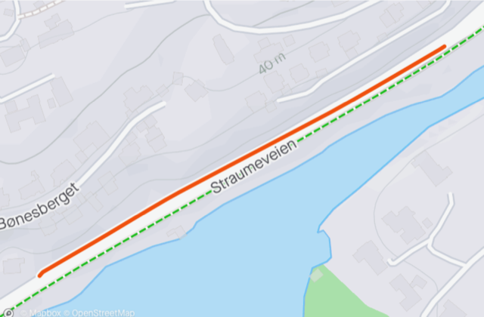

Start and end marked with nails and permanent spray on asphalt

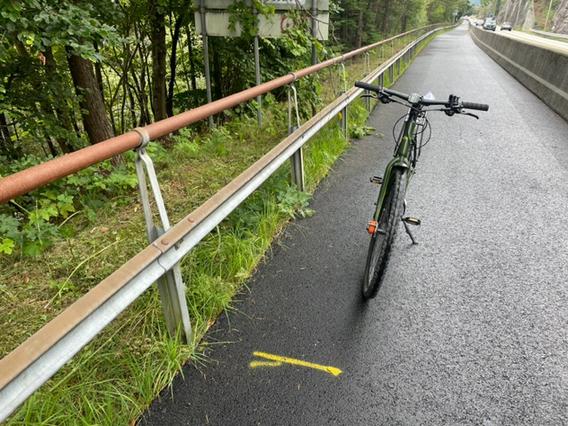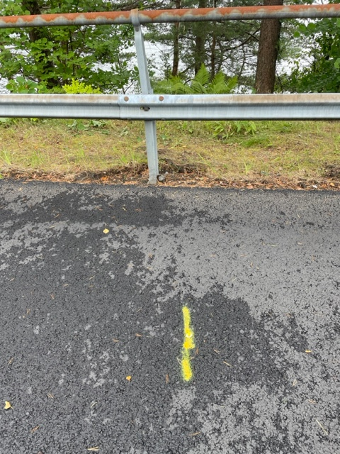

Figure 2 :COURSE MAP AND DESCRIPTION

Løypen går fra Torgallmenningen - inn i Rådhusgaten og videre i Kaigaten forbi jernbanen - videre på baksiden av bystasjonen og på gangvei forbi AdO. Løypen går så på gang/sykkelvei inn til Kronstadtunnellen og ned mot Møllendal kapell. Her går løypen på sykkelvei til Helikopterplassen og inn til høyre over gangbro. videre til Fløen og AdO og videre langs sjøen til gamle Nygårdsbro mot Solheimsvi ken. Løperne følger bryggekanten et stykke i Damsgårdsundet før de tar opp i Damsgårdsveien. I Damsgårdsveien løpes det på fortauet til Småpudden. Videre over Småpudden, gjennom Nygårdsparken, før løperne returnerer mot sentrum. Ved Media City løpes det opp til Johannes Bruns gate. Videre går løypen opp Hans Tanks gate og inn i Fosswinckels gate. Denne gaten følger løperne helt til de løper ned i Bohrs gate, inn i Vestre Torggate og rett frem til mål på Torgallmenningen.

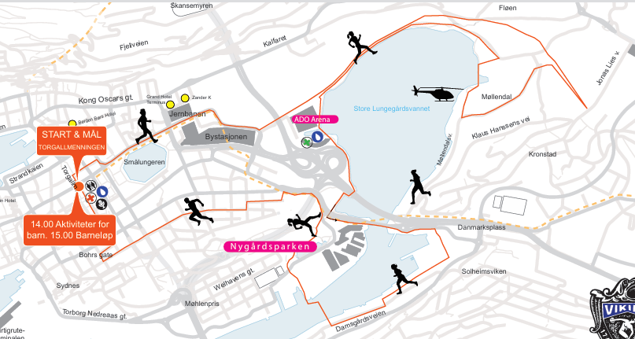

Figure 3 : Start/Finish line on Torgallmenningen

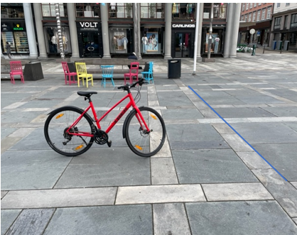

Figure 4 : Turning point in Kronstadtunellen

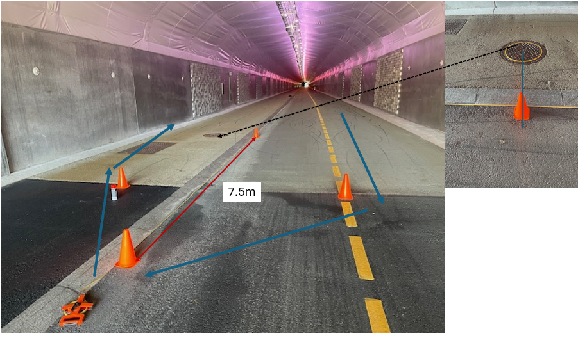

The turning point shown lies 45m longer away from the tunnel start than the preliminary point used in the measurement.
The distance from that point to the adjusted point was established using steel tape.
The point was measured to lie 7.5m after the last manhole before the end of the tunnel as shown on the figure. The start of the tunnel ( abt. 400m away) is seen on the picture.

