COURSE MEASUREMENT REPORT
- REPORT FOR NATIONAL CERTIFIED COURSE –
GENERAL INFORMATION
Event : Kalandseid Løpskarusell
Arrangør: Kalandseid IL
Location : Bergen
Date of event : June 2, 2025
Date and time for measurement: 22.05.2025, 11.00 AM
Distance to be measured : 3K, 5K and 10K
Length of calibration course : 350 m
Terrain: Flat Slightly hilly Hilly Terrain
Type of course route: Closed loop Back and forth A to B Other
Race surface: Asphalt
Elevation Start - Finish: 0m
Description of start: : Lamp post at start of bicycle path ( Figure 3 )
Description of finish: Same as Start
Distance, in a straight line, between start & finish: 0m
Start and Finish marked: Yes No
Km-markings: Yes No
Measurement direction: Running direction Opposite running direction
National record can be approved: Yes No

CONTACT INFORMATION
 | Measurer | Organizer: KALANDSEID IL
Kontaktperson: | Ivar Andreas Sandø | Erik Tonheim
Telefon: | +47 91648793 | +47 96626546
Epost: | Ivarsando53@gmail.com | erik@kalandseid.no

Det bekreftes herved, at løypa er oppmålt av en nasjonal sertifisert løypemåler fra Norsk friidrett. Løypa er oppmålt i henhold til Norsk friidretts bestemmelser, og distansen(e) har de(n) korrekte lengde(r). Oppmålingen gjelder i 5 år med unntak hvis traseen endres.

23.05.2025 Ivar A. Sandø
Dato Løypemålers underskrift Dato NFIFs godkjennelse

CALIBRATION COURSE INFORMATION ( Establishe in 2024 by Ivar Sandoe and Geir Jensen)
Length of measuring tape (steel measuring tape only) | 50m
Length of calibration course 1st measurement | 350,00m
Diifference between 1st and 2nd measurement | 0,02m
Possible 3. measurement | N/A
Cooose midpoint as 350.00 m mark | 350,00 m
Temperature (road or measuring tape) | +20C
Adjustment, jfr. D-(D*(1+(temp-20)*0,0000115) | 0 cm
Measured calibration distance after adjustment | 350,00 m
Distance from start/finish to calibration distance | 10k

CALIBRATION INFORMATION - (max 8 counts difference of 1000 m between 4 measurements, ie
2 counts of 300m and 3 count of 400m)
 | Pre measurement calibration |  |  | Post measuremnet calibration
 | Date and time: 22/5 10.45 AM |  |  | Date and time: 22/5 12.15 PM
 | Start | Stop | Diff. | Start | Stop | Diff.
1. Measurem. | 73363 | 81264 | 3901 | 35922 | 39825 | 3903
2. Measurem. | 81264 | 85165 | 3901 | 39825 | 43726 | 3901
3. Measurem. | 85165 | 89066 | 3901 | 43726 | 47628 | 3902
4. Measurem. | 89066 | 92968 | 3902 | 47628 | 51530 | 3902

Pre measurem. Post mesurem.
Average (1+2+3+4) / 4 | 3901,25 | 3902 | Today's constant. Either highest or average of before and after measurement
Counts 1 km | 11146,4 | 11148,6
Addition of 1‰ | 11,14 | 11,15
Constant (rounded o integer) | 11158 | 11160 | 11159
MÅLEPROSEDYRE
Measuring constant
11158
Measured distance (km) | Counter | Description of podition
0 | 98817 | Start
1,5 k | 115554 | Turning point 3K ,Figure 4
2,5K | 126712 | Turning point 5K, Figure 5
5K | 93115 | Turning point 10K, Figure 6.

Measuremnet description
- Measurement method
Measured using a Cook-Jones counter mounted on front whee

The course has identical start and finish line. ( Figure 3)
The course was measured in running direction from start line to the turning points for 3K, 5K and 10K.
Deviations from shortest path : NONE

- Determination of course length
The final constant is 11159 counts/km. The measuring constant was 11158.
This represents 9 cm / km. The turning points established in the measurements
are adjusted accordingly ( away from start/finish line)

Figure 1 : Calibration course

Figur 1 :350m calibration course in Straumevegen
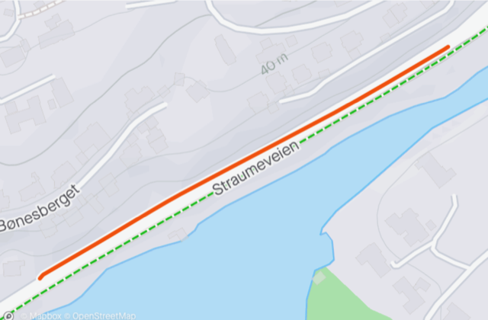

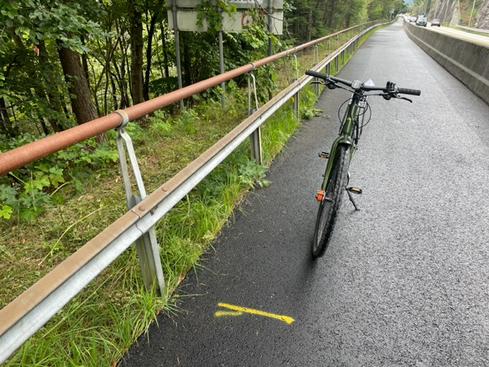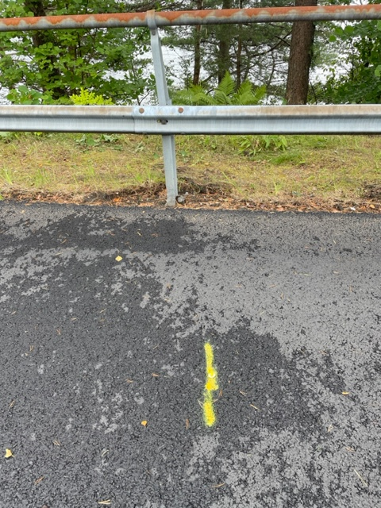

The calibration length is 350,00 m and marked with permanent spray og spikes on asphalt

Figure 2 : Course Map

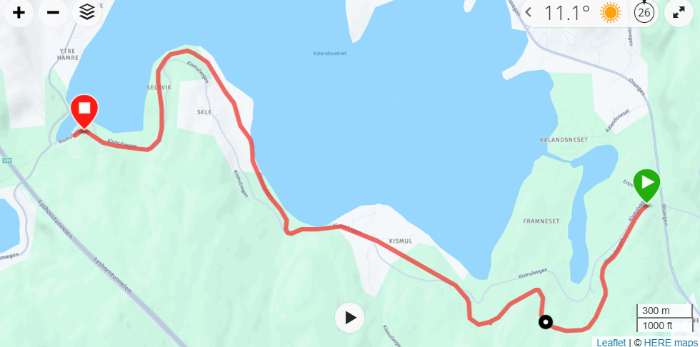

The course is a back and forth course, following the bicycle/footpath from Kalandseid to Hamre and back. The whole width of the path can be used in both directions.

Figur 3 : Start and finish line at Kalandseid

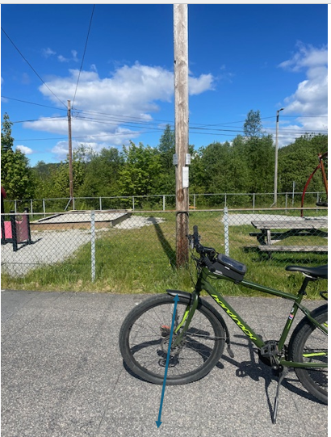

Start and finish line at Kalandseid – At the lamp post at start of the bicycle path

Figur 4 : Turning point 3K

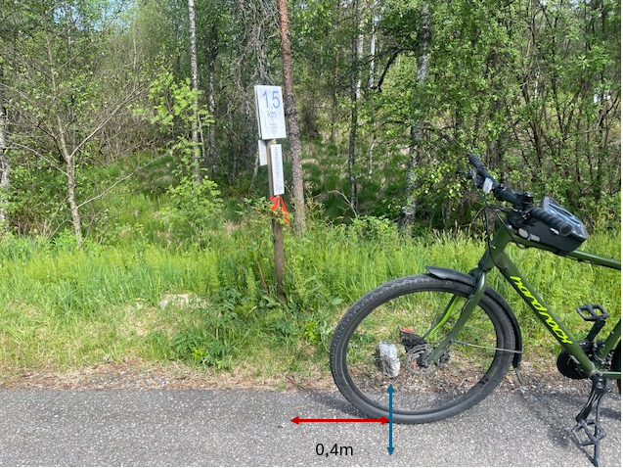

Turning point at 1.5 K : 0.4m ahead of the permanent marker post.

Figur 5 : Turning point 5K

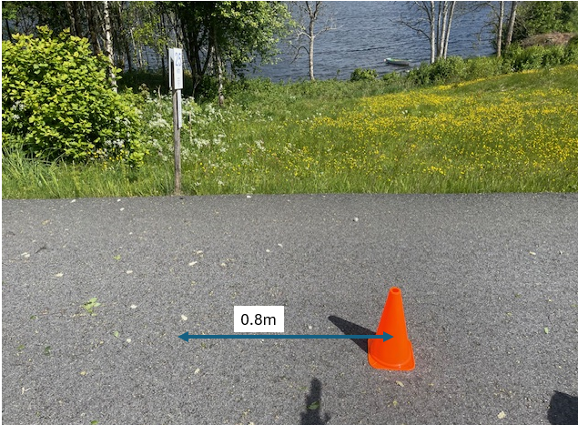

Turning point 5K : 0.8m ahead of the permanent marker post.

Figur 6 : Turning point 10K

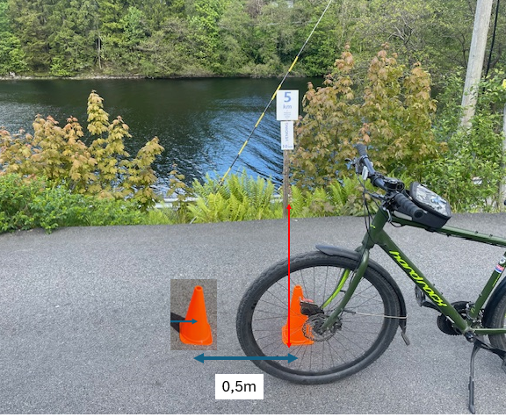

Turning point 10K : 0,5m after the permanent marker post

